# When climate policy meets social policy: a systematic map of the political economy literature

William F. Lamb

## Abstract

Eco-social policies are needed to deliver climate mitigation and provision human well-being, but face substantial challenges to uptake. In this paper we examine the evidence on how political economic contexts influence the design, adoption and outcomes of eco-social policies, specifically those that have both climate and social objectives. We perform a review of the literature using a systematic mapping methodology, coding study features such as method, context and results. We synthesize the findings in terms of identified policies and how they are shaped by interests, institutions and ideas.

## Long abstract

Climate change mitigation in line with the ambitions of the Paris Agreement will induce major shifts in energy supply and use (Allen et al., 2018). This energy transition to net zero emissions, supported by low patterns of demand in end-use sectors, has wide-ranging social aspects. Social co-benefits from mitigation can be achieved through policies that promote low-carbon forms of human well-being satisfaction, such as decentralised modern energy access, active travel and low-carbon mobility, or high quality energy efficient housing (Creutzig et al., 2016; Lamb and Steinberger, 2017). A wide range of ‘eco-social’ policies have been suggested, such as green fiscal reform, recycling carbon tax revenues into social provisioning, low-carbon social housing, or a green new deal. But against these opportunities are the social risks of an energy transition policies: fossil fuel subsidy reforms are often (but not always) regressive (Lockwood, 2015), while rising energy prices can push low-income households into energy poverty (Frondel et al., 2015).

The meeting point of climate and social policy is in the political economy: it is the confluence of *interests*, *institutions* and *ideas* that will ultimately determine whether mitigation policies capture social co-benefits, or exacerbate social divisions. For instance, *interests* such as incumbent energy providers, labour unions, and different social classes will each aim to shape policy to their advantage, but often have competing preferences and highly varied levels of access to political power (Fuchs et al., 2015). Thus even mitigation policies that are effective and promote human well-being across a large majority of the population could fail to be adopted (Jakob et al., 2016). Similarly, pre-existing *institutions* can determine the possibility space for policies, as for instance when governance arrangements are exposed to veto players that can unilaterally block reform (Lockwood et al., 2016). Not least, the wider environment of *ideas* propagated in society – attitudes, norms, preferences – are highly determinant of action, such as the ubiquitous norm in Western societies against government intervention in deeply individual aspects of everyday life (e.g. transportation or food preferences) (Geels et al., 2017).

There is a substantive literature on the political economy of energy transitions (Geels et al., 2017; Sovacool and Hess, 2017). There is also a large literature on social aspects of climate mitigation, including the distributional (income) implications of climate policy design (Dorband et al., 2019), the role of welfare states in climate policy (Gough, 2016; Koch and Fritz, 2014), and the linkages between human well-being and energy access (Brand-Correa et al., 2018; Lamb and Steinberger, 2017; Mattioli, 2016; Rao and Min, 2017). There is a clear gap and missing overview of where these two literatures meet, i.e. on the political economy of policies that have both climate and social objectives. Some review studies do address the political economy of specific epistemic concerns, such as energy poverty (Sovacool, 2012), just transitions (Newell and Mulvaney, 2013), and climate and development (Tanner and Allouche, 2011). However, we do not find any systematic reviews addressing individual issues, nor any on the broad political economy of social aspects in climate mitigation[1].

The research question for this project is: *What evidence is there that political economic contexts influence the design, adoption and outcomes of policies with both climate and social objectives?* We define climate objectives as policies or measures that lower the carbon intensity of the energy system, or reduce overall energy demand. We define social objectives as those that aim to improve or sustain human well-being, specifically through reduced inequalities, access to modern energy services, mobility (transportation) and housing. Finally, we follow the literature on comparative political economy and define three elements of context that are critical for policy reform: the balance of social interests and stakeholders, the role of institutions (public and private), and the influence of prevailing ideas.

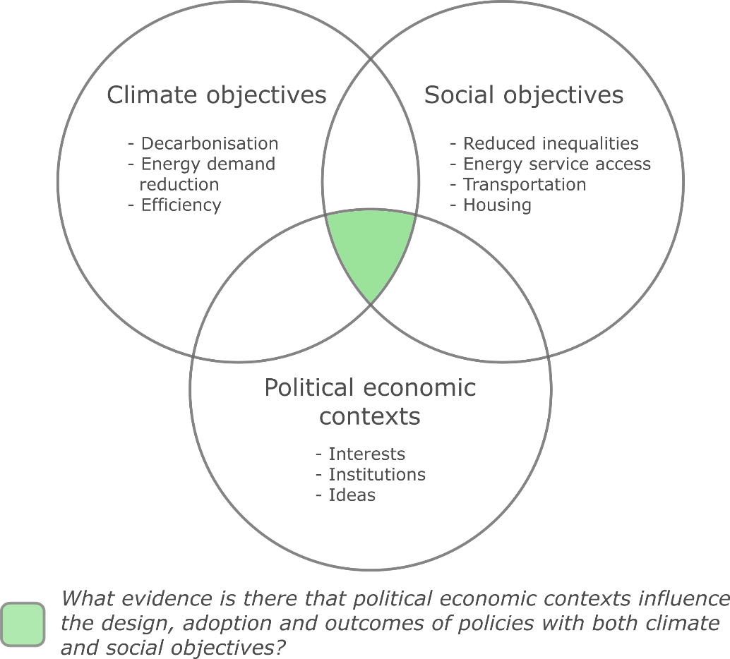

**Figure 1: Scope of the intended project**

Due to the broad scope, interdisciplinary and fragmented nature of the literature, this is review project will adopt a systematic mapping methodology (Haddaway et al., 2016; James et al., 2016). In short, we aim to identify the nature and extent of the literature base, with the following specific objectives:

* Identify the relevant studies using literature database searches and a call for evidence
* Characterise each study in terms of the examined: (1) mitigation objective(s); (2) social objective(s); (3) political economic context(s)
* Characterise each study in terms of method (quantitative/qualitative), scale (national, urban, community-level) and epistemic community (discipline)
* Synthesize the results, focusing on research gaps and areas for consolidation, suggested policies, key drivers and barriers of reform, conceptual differences in political economy analysis

The window for meeting the goals set out in the Paris Agreement is rapidly closing. We perceive a strong need for this review, in light of currently missing but critically important short-term entry points to climate policy. At the same time, escalating social conflicts in both the global North and South underline the need to consider social objectives in the design of climate policy – and to identify the most promising strategies to see these through to adoption. Our review will inform stakeholders of the available options and the potential barriers they face; it will also provide an important foundation for continued work in this area.

## References

Allen, M., Babiker, M., Chen, Y., Coninck, H. de, Connors, S., Diemen, R. van, Dube, O.P., Ebi, K., Engelbrecht, F., Ferrat, M., Ford, J., Forster, P., Fuss, S., Guillen, T., Harold, J., Hoegh-Guldberg, O., Hourcade, J.-C., Huppmann, D., Jacob, D., Jiang, K., Johansen, T.G., Kainuma, M., Kleijne, K. de, Kriegler, E., Ley, D., Liverman, D., Mahowald, N., Masson-Delmotte, V., Matthews, R., Melcher, R., Millar, R., Mintenbeck, K., Morelli, A., Moufouma-Okia, W., Mundaca, L., Nicolai, M., Okereke, C., Pathak, M., Payne, A., Pidcock, R., Pirani, A., Poloczanska, E., Pörtner, H.-O., Revi, A., Riahi, K., Roberts, D.C., Rogelj, J., Roy, J., Seneviratne, S., Shukla, P.R., Skea, J., Slade, R., Shindell, D., Singh, C., Solecki, W., Steg, L., Taylor, M., Tschakert, P., Waisman, H., Warren, R., Zhai, P., Zickfeld, K., 2018. Summary for Policymakers, in: Global Warming of 1.5oC: An IPCC Special Report on the Impacts of Global Warming of 1.5oC above Pre-Industrial Levels and Related Global Greenhouse Gas Emissions Pathways, in the Context of Strengthening the Global Response to the Threat of Climate Change. Cambridge University Press, Cambridge, United Kingdom and New York, NY, USA.

Brand-Correa, L.I., Martin-Ortega, J., Steinberger, J.K., 2018. Human Scale Energy Services: Untangling a “golden thread.” Energy Res. Soc. Sci. 38, 178–187. doi:10.1016/j.erss.2018.01.008

Creutzig, F., Fernandez, B., Haberl, H., Khosla, R., Mulugetta, Y., Seto, K.C., 2016. Beyond Technology: Demand-Side Solutions for Climate Change Mitigation. Annu. Rev. Environ. Resour. 41, 173–198. doi:10.1146/annurev-environ-110615-085428

Dorband, I.I., Jakob, M., Kalkuhl, M., Steckel, J.C., 2019. Poverty and distributional effects of carbon pricing in low- and middle-income countries – A global comparative analysis. World Dev. 115, 246–257. doi:10.1016/j.worlddev.2018.11.015

Frondel, M., Sommer, S., Vance, C., 2015. The burden of Germany’s energy transition: An empirical analysis of distributional effects. Econ. Anal. Policy 45, 89–99. doi:10.1016/j.eap.2015.01.004

Fuchs, D., Di Giulio, A., Glaab, K., Lorek, S., Maniates, M., Princen, T., Røpke, I., 2015. Power: The missing element in sustainable consumption and absolute reductions research and action. J. Clean. Prod. 132, 298–307. doi:10.1016/j.jclepro.2015.02.006

Geels, F.W., Sovacool, B.K., Schwanen, T., Sorrell, S., 2017. The Socio-Technical Dynamics of Low-Carbon Transitions. Joule 1–17. doi:10.1016/j.joule.2017.09.018

Gough, I., 2016. Welfare states and environmental states: a comparative analysis. Env. Polit. 25, 24–47. doi:10.1080/09644016.2015.1074382

Haddaway, N.R., Bernes, C., Jonsson, B.G., Hedlund, K., 2016. The benefits of systematic mapping to evidence-based environmental management. Ambio 45, 613–620. doi:10.1007/s13280-016-0773-x

Jakob, M., Chen, C., Fuss, S., Marxen, A., Rao, N.D., Edenhofer, O., 2016. Carbon Pricing Revenues Could Close Infrastructure Access Gaps. World Dev. 84, 254–265. doi:10.1016/j.worlddev.2016.03.001

James, K.L., Randall, N.P., Haddaway, N.R., 2016. A methodology for systematic mapping in environmental sciences. Environ. Evid. 5, 1–13. doi:10.1186/s13750-016-0059-6

Koch, M., Fritz, M., 2014. Building the eco-social state: Do welfare regimes matter? J. Soc. Policy 43, 679–703. doi:10.1017/S004727941400035X

Lamb, W.F., Steinberger, J.K., 2017. Human well-being and climate change mitigation. Wiley Interdiscip. Rev. Clim. Chang. 8, 1–16. doi:10.1002/wcc.485

Lockwood, M., 2015. Fossil Fuel Subsidy Reform , Rent Management and Political Fragmentation in Developing Countries. New Polit. Econ. 20, 475–494. doi:10.1080/13563467.2014.923826

Lockwood, M., Kuzemko, C., Mitchell, C., Hoggett, R., 2016. Historical institutionalism and the politics of sustainable energy transitions : A research agenda. doi:10.1177/0263774X16660561

Mattioli, G., 2016. Transport needs in a climate-constrained world. A novel framework to reconcile social and environmental sustainability in transport. Energy Res. Soc. Sci. 18, 118–128. doi:10.1016/j.erss.2016.03.025

Newell, P., Mulvaney, D., 2013. The political economy of the “just transition.” Geogr. J. 179, 132–140. doi:10.1111/geoj.12008

Rao, N.D., Min, J., 2017. Decent Living Standards: material prerequisites for human wellbeing. Soc. Indic. Res. doi:10.1007/s11205-017-1650-0

Sovacool, B.K., 2012. The political economy of energy poverty: A review of key challenges. Energy Sustain. Dev. 16, 272–282. doi:10.1016/j.esd.2012.05.006

Sovacool, B.K., Hess, D.J., 2017. Ordering theories: Typologies and conceptual frameworks for sociotechnical change. Soc. Stud. Sci. 47, 703–750. doi:10.1177/0306312717709363

Tanner, T., Allouche, J., 2011. Towards a New Political Economy of Climate Change and Development. IDS Bull. 42, 1–14. doi:10.1111/j.1759-5436.2011.00217.x

1. Based on a Web of Science and Scopus topic search, refining by reviews, using the following keywords: (("climat*" OR "energy") AND ("wellbeing" OR "welfare" OR "social" OR "well-being" OR "poverty" OR "human need") AND ("political econom*"))